**TUGAS PRAKTIKUM**

**PENGEMBANGAN APLIKASI WEB**

**MODUL 5**

**“Database MySQL”**



**Disusun Oleh:**

Nama : Ari Andi Mustofa

NIM : 200411100133

Kelas : PAW-4B

**Dosen Pengampu:**

Nama : Ach. Khozaimi,S.Kom,M.Kom.

NIP : 198609262014041001

**Asisten Praktikum:**

Nama : Alief Fadhilah Athallariq

NIM : 180411100028

**PRODI TEKNIK INFORMATIKA**

**JURUSAN TEKNIK INFORMATIKA  
FAKULTAS TEKNIK**

**UNIVERSITAS TRUNOJOYO MADURA**

**2022**

**Tugas Praktikum :**

1. Buatlah sebuah database mahasiswa yg berisi table dengan nama tbl_mahasiswa dengan record nrp, nama, email, dan alamat.

Jawab :

* + 1. 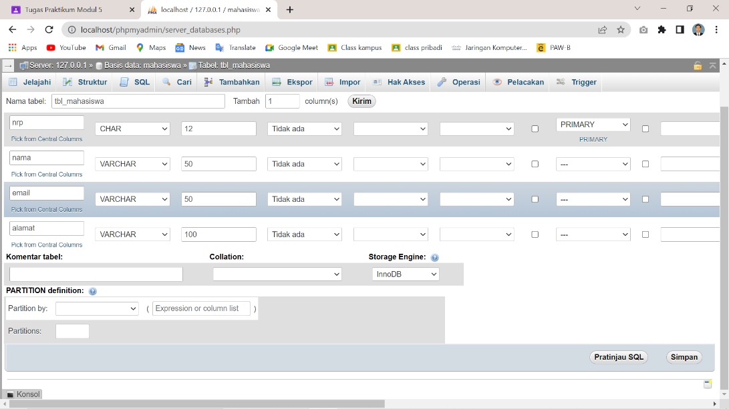Membuat tabel mahasiswa
    2. Hasil tabel

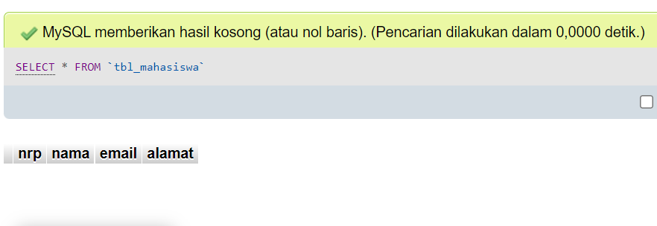

1. Buatlah beberapa file php yang dapat memasukkan, menampilkan, meng-update dan menghapus data yang ada dalam database mahasiswa tersebut!

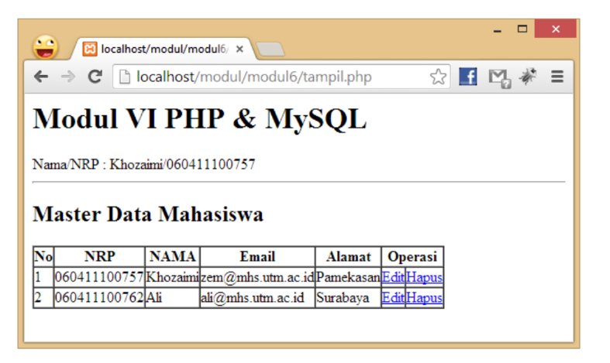

Jawab :

1. Code Koneksi

<?php

$host='localhost';

$user='root';

$password='';

$db='mahasiswa';

$connect=mysqli_connect($host,$user,$password,$db);

if(!$connect){

    echo "<script> alert('Gagal Terhubung') </script>";

}

?>

1. Code Tabel

<!DOCTYPE html>

<html lang="en">

<head>

    <meta charset="UTF-8">

    <meta http-equiv="X-UA-Compatible" content="IE=edge">

    <meta name="viewport" content="width=device-width, initial-scale=1.0">

    <link href="https://cdn.jsdelivr.net/npm/bootstrap@5.1.3/dist/css/bootstrap.min.css" rel="stylesheet">

    <title>Tabel</title>

</head>

<body>

    <h1>Modul V PHP dan MySQL</h1>

    <p>nama/nrp : Ari Andi Mustofa</p>

    <hr>

    <h2>Master Data Mahasiswa</h2>

    <button style="border:1px solid;"><a href="form.php" style="text-decoration: none;">Tambah</a></button>

    <table class="table">

        <tr>

            <td>No.</td>

            <td>NRP</td>

            <td>Nama</td>

            <td>Email</td>

            <td>Alamat</td>

            <td>Operasi</td>

        </tr>

        <?php

        include "koneksi.php";

        $query="SELECT*FROM tbl_mahasiswa";

        $hasil=mysqli_query($connect,$query);

        while ($row=mysqli_fetch_array($hasil)){

        ?>

        <tr>

            <td><?php echo $row['nomor'] ?></td>

            <td><?php echo $row['nrp'] ?></td>

            <td><?php echo $row['nama'] ?></td>

            <td><?php echo $row['email'] ?></td>

            <td><?php echo $row['alamat'] ?></td>

            <td>

                <a href="form edit.php?no=<?php echo $row['nomor']; ?>" style="text-decoration: none;">Edit</a> |

                <a href="delete.php?no=<?php echo $row['nomor']; ?>" style="text-decoration: none;">Hapus</a>

            </td>

        </tr>

        <?php

        }

        ?>

    </table>

</body>

</html>

Hasil

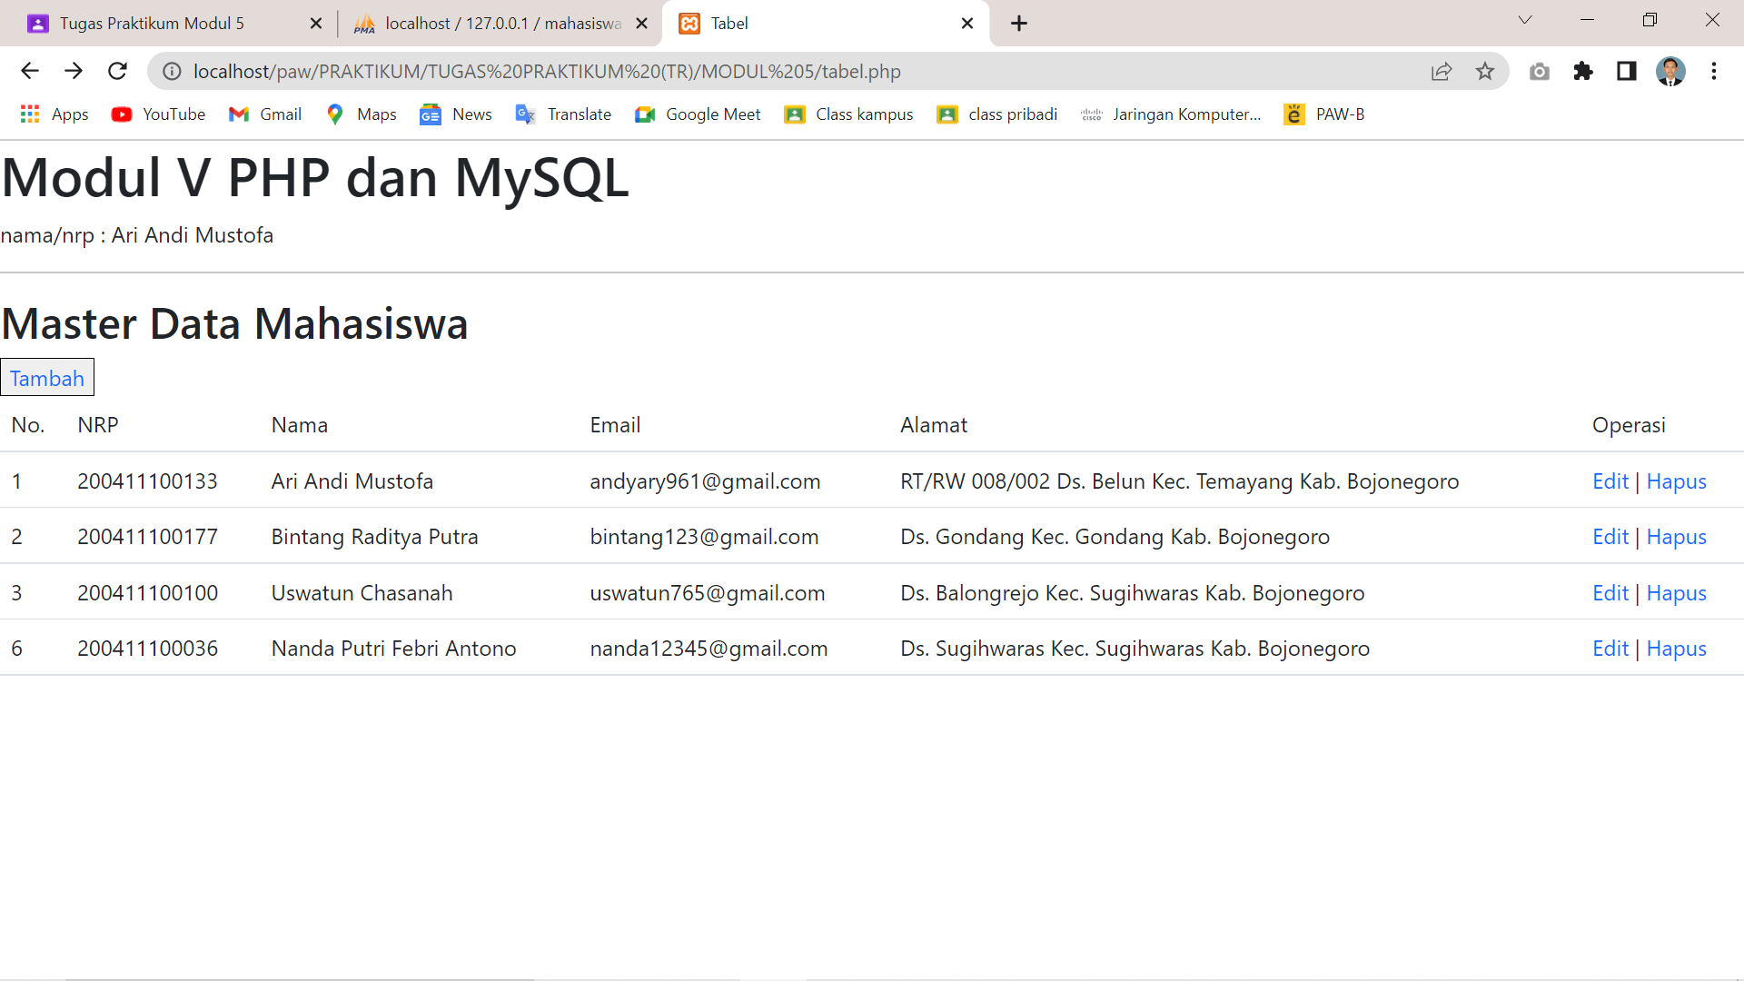

1. Code Form Tambah

<!DOCTYPE html>

<html lang="en">

<head>

    <meta charset="UTF-8">

    <meta http-equiv="X-UA-Compatible" content="IE=edge">

    <meta name="viewport" content="width=device-width, initial-scale=1.0">

    <title>Form</title>

</head>

<body>

    <h2>Tambah Mahasiswa</h2>

    <form action="action.php" method="POST">

        <div style="padding-bottom: 10px;">

            <label for="">NRP</label><br>

            <input type="text" name="nrp" ><br>

        </div>

        <div style="padding-bottom: 10px;">

            <label for="">Nama</label><br>

            <input type="text" name="nama"><br>

        </div>

        <div style="padding-bottom: 10px;">

            <label for="">email</label><br>

            <input type="text" name="email"><br>

        </div>

        <div style="padding-bottom: 10px;">

            <label for="">alamat</label><br>

            <input type="text" name="alamat"><br>

        </div>

        <button type="submit">Tambah</button>

    </form>

</body>

</html>

Hasil :

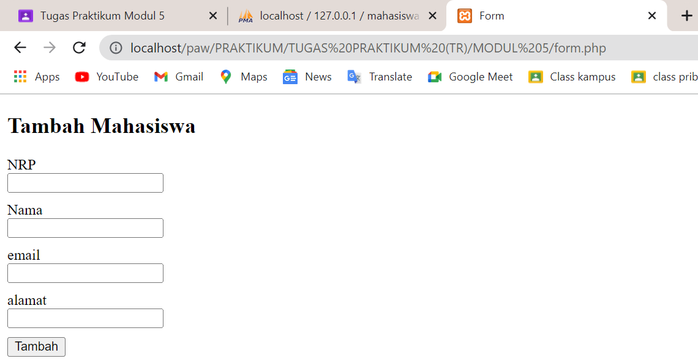

1. Code Action Tambah

<?php

    include "koneksi.php";

    $nrp=$_POST['nrp'];

    $nama=$_POST['nama'];

    $email=$_POST['email'];

    $alamat=$_POST['alamat'];

    $sql="INSERT INTO tbl_mahasiswa VALUES (null,'$nrp','$nama','$email','$alamat')";

    $hasil=mysqli_query($connect,$sql);

    if(!$hasil){

            echo "<script>alert('Berhasil ditambahkan')</script>";

    } else {

            echo "<script>alert('Gagal ditambahkan')</script>";

    }

?>

1. Code Action Delete

<?php

include "koneksi.php";

$no=$_GET['no'];

$query="DELETE FROM tbl_mahasiswa WHERE nomor='$no'";

$hasil=mysqli_query($connect,$query);

if(!$hasil){

    echo "<script>alert('gagal Menghapus')</script>";

} else {

    echo "<script>alert('berhasil Menghapus')</script>";

}

?>

1. Code Form Edit

<!DOCTYPE html>

<html lang="en">

<head>

    <meta charset="UTF-8">

    <meta http-equiv="X-UA-Compatible" content="IE=edge">

    <meta name="viewport" content="width=device-width, initial-scale=1.0">

    <title>Form Edit</title>

</head>

<body>

    <h2>Edit Mahasiswa</h2>

    <?php

        include "koneksi.php";

        $no=$_GET['no'];

        $sql="SELECT * FROM tbl_mahasiswa WHERE nomor='$no'";

        $hasil=mysqli_query($connect,$sql);

        if (!$hasil){

            echo "Query Salah";

        }

        ?>

        <?php

        while($row=mysqli_fetch_array($hasil))

        {

        ?>

        <form action="edit.php" method="POST">

        <input type="hidden" name="no" value="<?php echo $row['nomor'] ?>">

            <div style="padding-bottom: 10px;">

                <label for="">NRP</label><br>

                <input type="text" name="nrp" value="<?php echo $row['nrp'] ?>"><br>

            </div>

            <div style="padding-bottom: 10px;">

                <label for="">Nama</label><br>

                <input type="text" name="nama" value="<?php echo $row['nama'] ?>"><br>

            </div>

            <div style="padding-bottom: 10px;">

                <label for="">email</label><br>

                <input type="text" name="email" value="<?php echo $row['email'] ?>"><br>

            </div>

            <div style="padding-bottom: 10px;">

                <label for="">alamat</label><br>

                <input type="text" name="alamat" value="<?php echo $row['alamat'] ?>"><br>

            </div>

            <button type="submit">Edit</button>

        </form>

        <?php } ?>

</body>

</html>

Hasil :

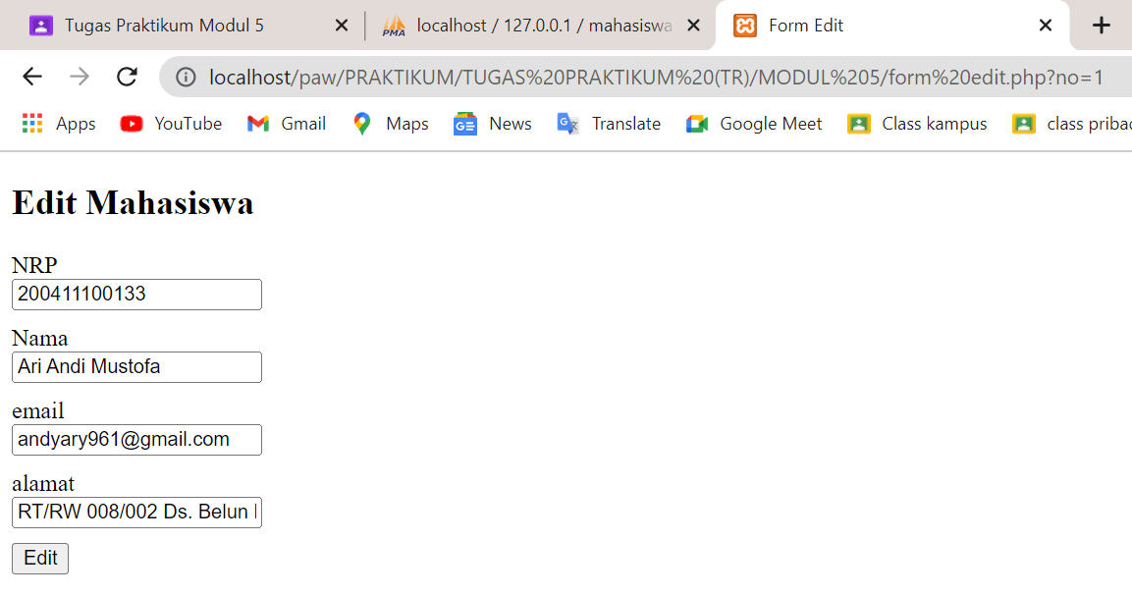

1. Code Action Edit

<?php

    include "koneksi.php";

    $no=$_POST['no'];

    $nrp=$_POST['nrp'];

    $nama=$_POST['nama'];

    $email=$_POST['email'];

    $alamat=$_POST['alamat'];

    $sql="UPDATE tbl_mahasiswa SET nrp='$nrp',nama='$nama',email='$email',alamat='$alamat' WHERE nomor='$no'";

    $hasil=mysqli_query($connect,$sql);

    if(!$hasil){

            echo "<script>alert('gagal Mengubah')</script>";

    } else {

        echo "<script>alert('berhasil Mengubah')</script>";

    }

?>